Actual Json mapping happens here
Here, Download button will download a ZIP that will consist DB scripts for following collections
- IntegrationMappings
- IntegrationCallsMeta
- InsurerMeta (Optional)
- MasterCollection (Optional)

In Mappings, you can see List of BFs as expandable rows
The Expanded table will consist of each Business step with 7 columns as follows
- Meta
  - General Meta Information about Step
  - Processing Instructions (skip step, utility mode, use Response as Request)
- API Configuration
  - This is copied from API details to here, Can edit/ add new (For UAT)
- Request
  - One Left hand side, you can see the Insurer Payload. This is the final payload to sent to Provider as request body
  - On the right hand side, there is a form. This is the actual mapping.You can select any key from payload and Fill in the right form.
  - Form is divided into 3 sections
    - Analysis
    - Turtlemint Source
    - Mappings Details
      - Here you can select To and From
      - Rules
        - In rules, you can give simple as well as complex rules supported by ifv. (Integration framework)
  - Summary
    - You also have a summary section for mappings marked as need clarification
    - Here you can escalate these doubts to Insure via Escalate button
  - You can see same mappings in a summarized from in GRID view
  - Unit Tests
    - You can add unit tests for each and every mapping.
    - These Unit tests will be executed via integration-framework (the rule engine).
    - Here you can give in the scope and expectations. Run execute to see results
- Request Post Processing
  - Rules for Request Post processing can be added here against any key from payload
- Response Pre Processing
  - Similar to Request Post Processing
- Response
  - Similar to Request, just an addition
  - Response support multiple mappings against same key from payload
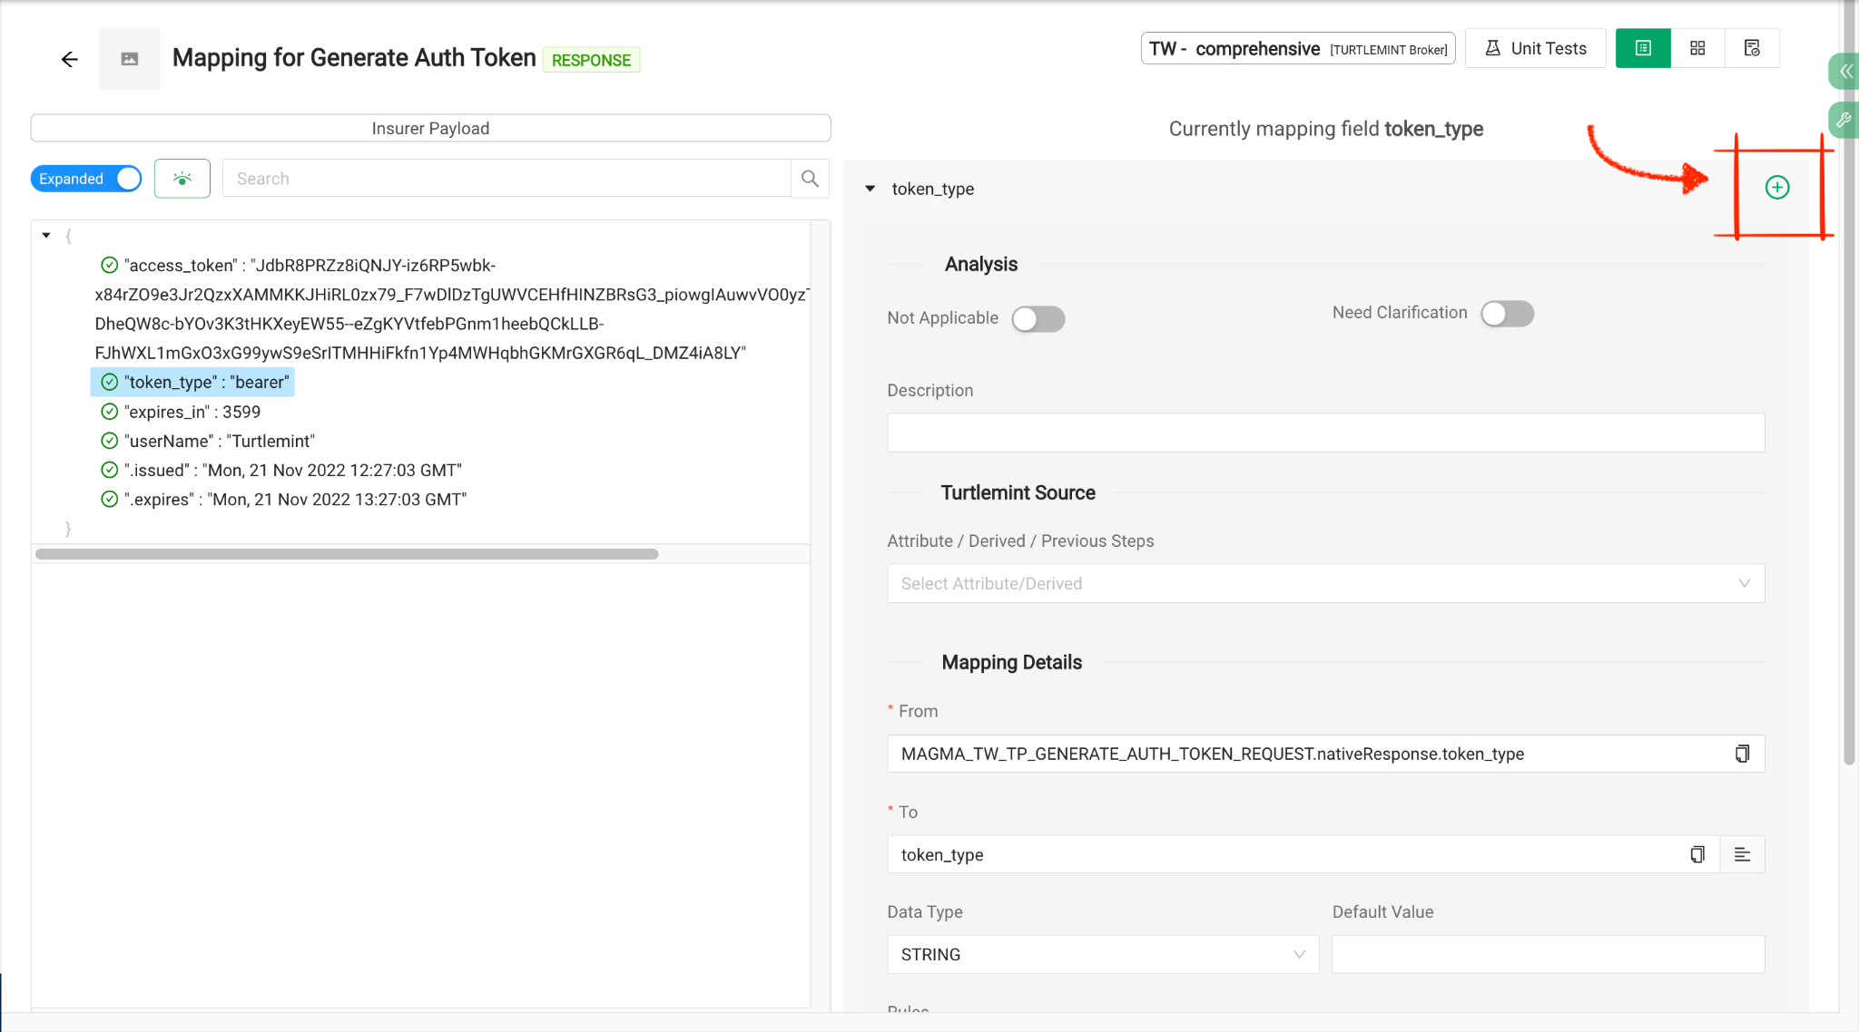
- Other
  - API Testing, you can actually test your developed mappings here
    - Need to provide scope and hit execute
    - You can execute Raw or Normal
  - Unit Test Dashboard
    - DashBoard to handle Unit test form each step at one place
    - You can click on execute to run all unit tests at once

Developer Planning:
- Development

Planing

Setting
    - Integrated Insurer
    - Master collection
    - Insurer Meta
    - The Above data will also be downloaded in artifact zip

Mapping
    - Here you can do actual mappings and export the mappings json
    - Explained in detail here

Dev Testing
    - Here are the actual test cases proved by Provider, You can also add your own test cases if any
    - Add in UAT button will automatically add the custom test case to UAT test cases

Mapping Form Fields:
- Analysis
  - Not Applicable:
    - Used when a field is not applicable in mapping
  - Need Clarification
    - Used when in doubt and need to ask Provider about a field
    - Clarification Text:
      - To be sent in Email
    - Resolved:
      - Mark if the doubt is resolved
  - Description
- Turtlemint Source
  - Attribute / Derived / Previous steps
  - Example
- Mapping Details
  - From
    - Get this field from ?
    - In request mapping, you can select From from a payload
  - To
    - Map this field to ?
    - In response mapping, you can select To from a payload
  - DataType
  - Default Value
  - Rules
    - Here you can add different rules supported by ifv
  - Include if null
    - Mark if you want to add this field in payload even if its null
  - Is List
    - List Type
    - To Parent Path
    - From Parent Path

Page Header of Integration
- Left Side
  - Logo
  - Sub Module
  - Product Name
  - Broker
- Center
  - Current Stage
- Right Side
  - Mark complete
    - Use this to mark a stage complete
  - Communication
    - Use this to send email for the current stage

